USING THE iNATURALIST APPLICATION

What you will need:
- Smart phone
- Shoes for walking

- Download the iNaturalist application from your smart phone’s app store (it’s free!) and sign-in.

- Follow the instructions for your device (Apple or Android smartphones, or if you don’t have a smartphone, a web browser on a standard computer) to make an observation!

[The following are instructions provided by iNaturalist]
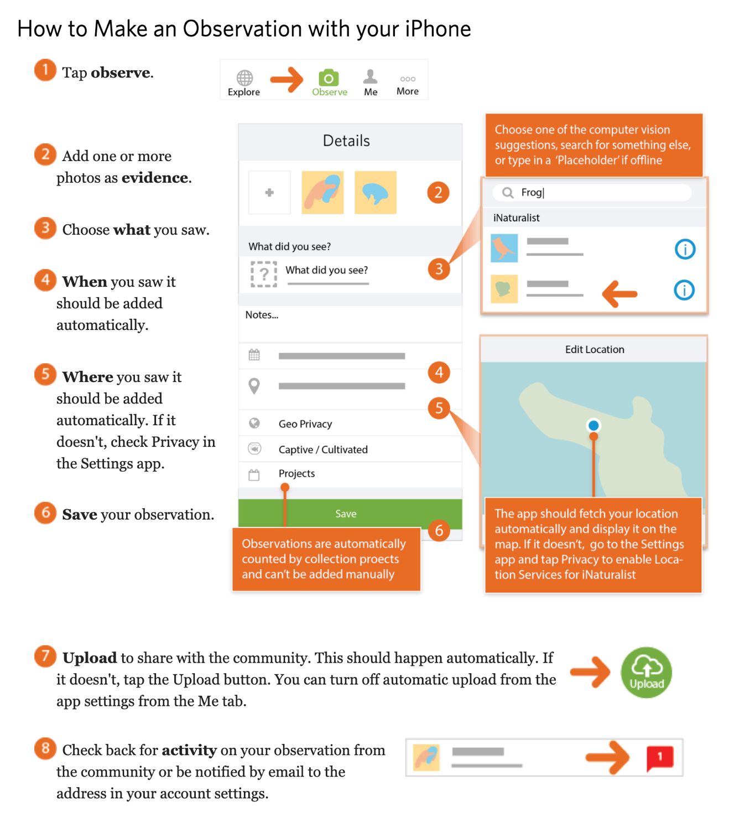

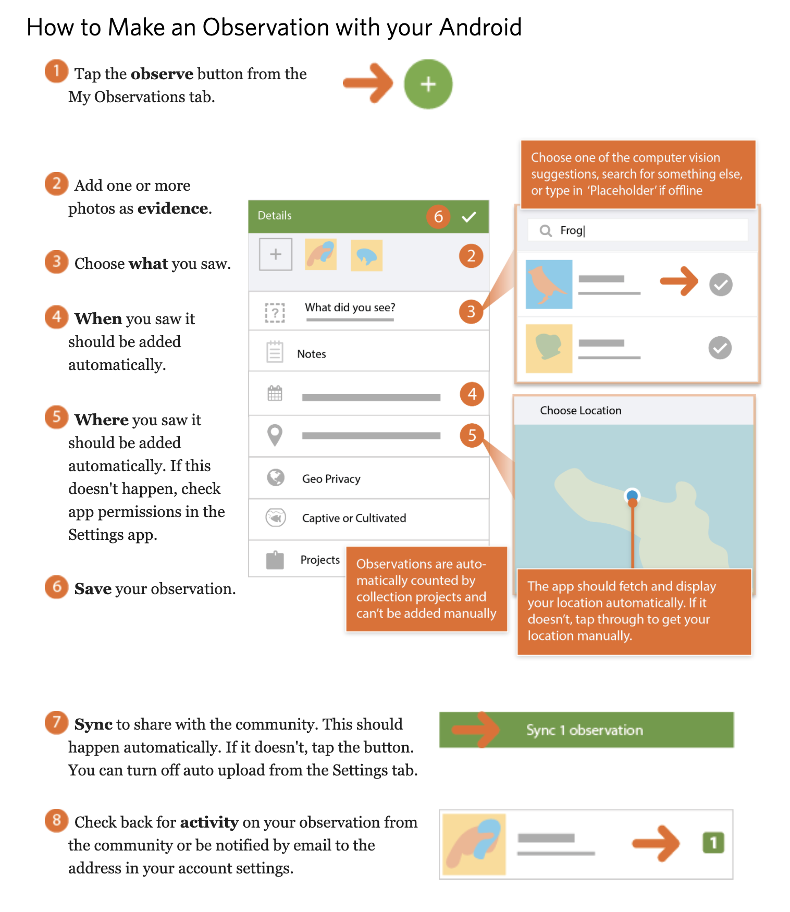

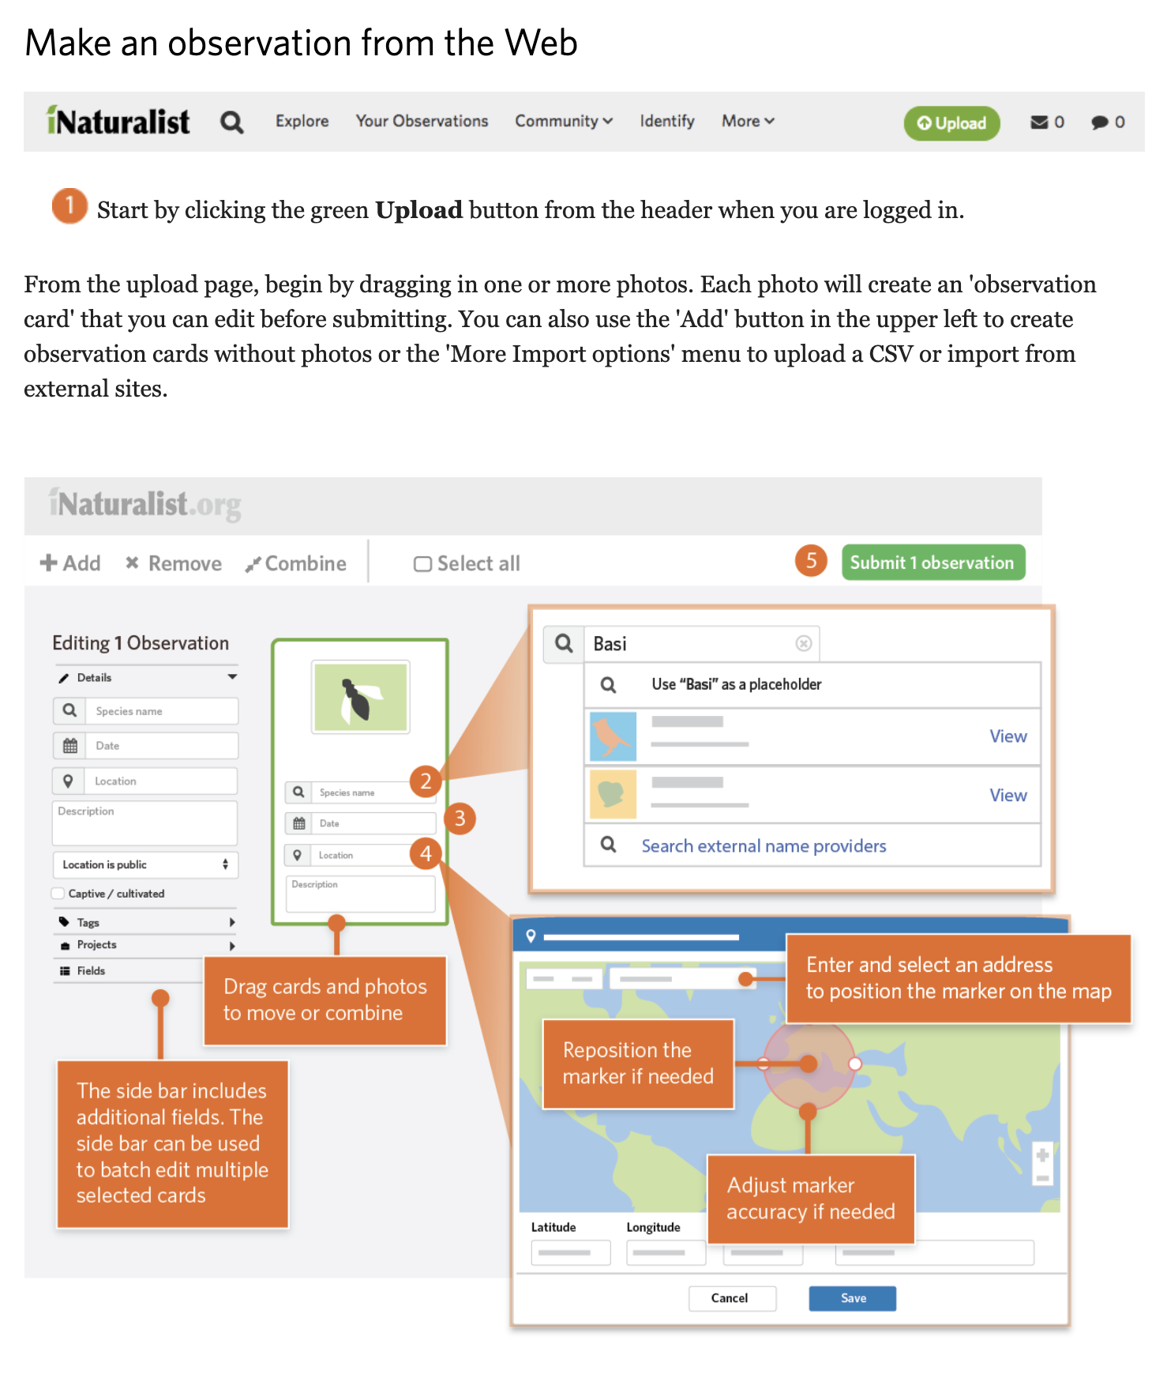

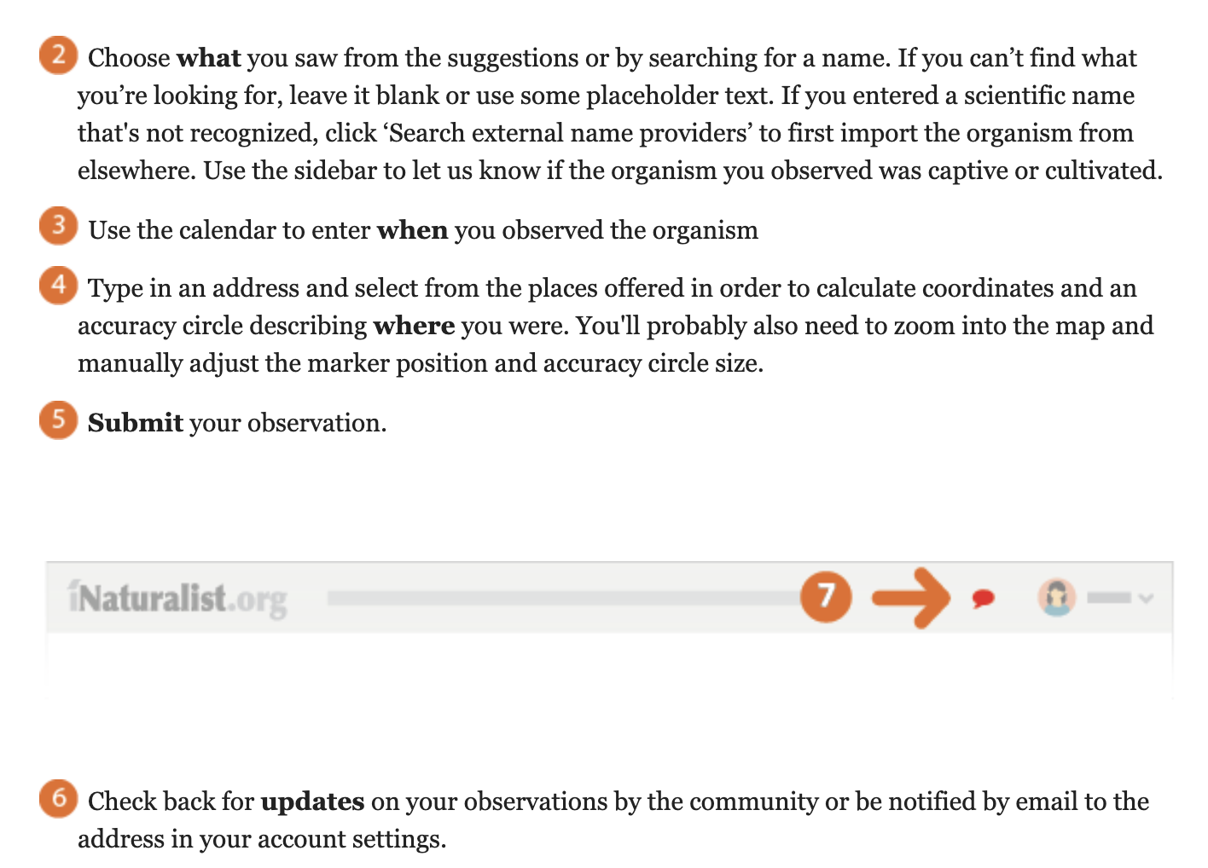

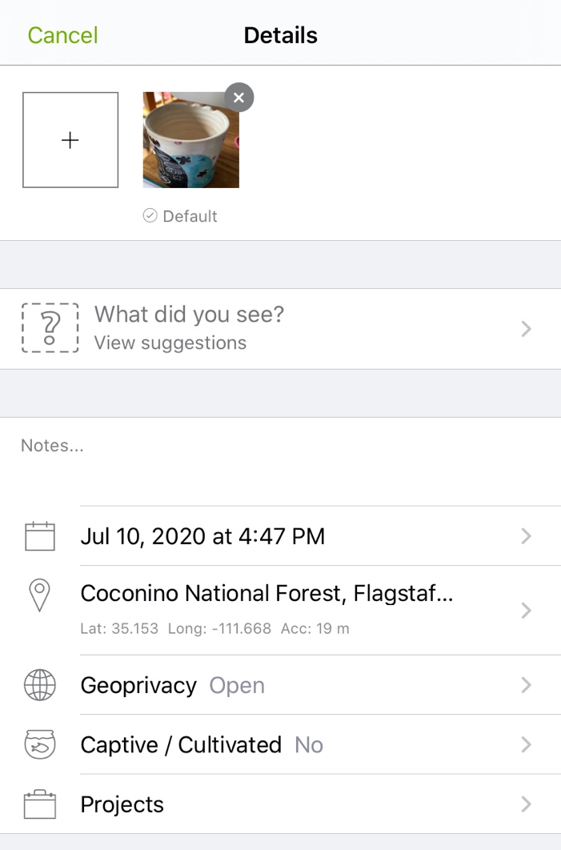
- Take good plant pictures!

Botanists use certain traits to identify plant species. In order to be able to identify plants from pictures, captures these features when you make your observations. After you take your first picture, hit ‘Next’. You will see the picture that you have just taken and next to it a square containing a plus sign. You can take multiple pictures by clicking on the plus button!

Be sure you capture pictures of:
- Flowers or fruit (This is critically important – species level identification is often impossible without seeing flowers or fruit).
- The overall growth form of the plant.
- A close-up of plant leaves. Check the bottom of the plant to see if the leaves on the stem are different from any leaves that might be growing at the bottom of the plant near the ground – take pictures of both types of leaves.
- Any unusual features like hairs, thorns, or tendrils.

- Don’t know the species name of the plant for which you are making an observation?
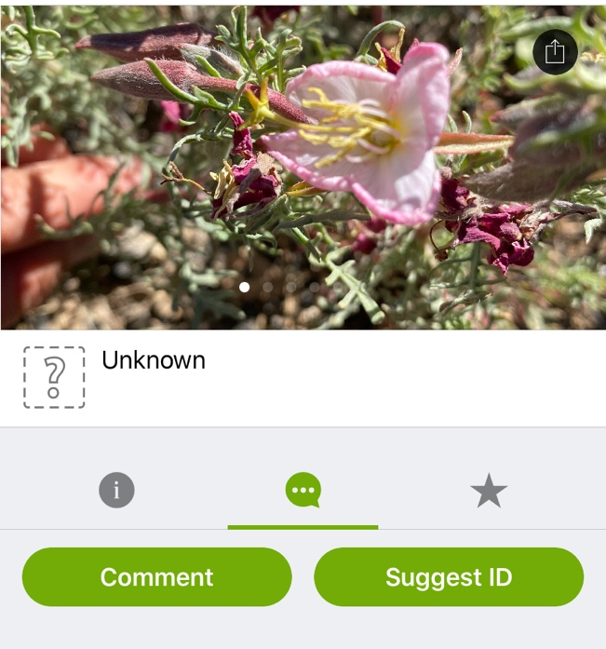
Hit the center icon (looks like a comment bubble) and select ‘Suggest ID’. A list of possible species will be generated. Look through the list and pick the most likely option (either by visual assessment, by proximity, or both). Don’t worry – this observation will be shipped out to the iNaturalist community, who will help with Identification.

You are collecting lots of great information on the natural world when you make these observations! By using a smart phone, you will record what you saw, where you saw it, and when you observed it.

